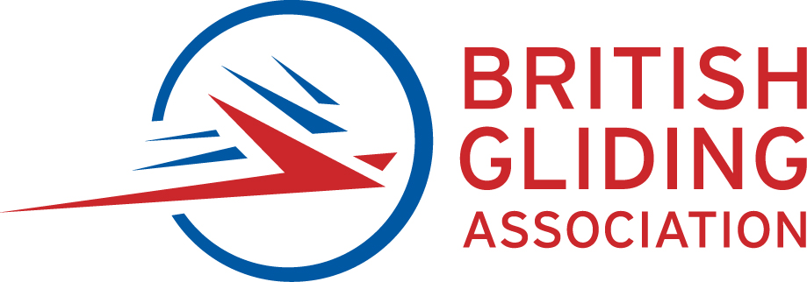BGA COMPETITION REGISTRATION FORM

Read this form carefully. All questions must be answered and the Declaration signed. The BGA and the Organisation reserves the right to call for verification of any answers given. Please note that incorrect answers may lead to rejection of your entry or disqualification.
Competition: |  |  |  | Dates |  |  |  | to
Organising Club:
First Pilot Name: |  |  |  |  |  | Comp Licence No:
Second Pilot Name: |  |  |  |  |  | Comp Licence No:
First Pilot Mobile No: |  |  | First Pilot Email:
Chief Crew Name: |  |  | Chief Crew Mobile:
Glider Type: |  | Span (m):
Registration: |  | Competition Markings:
Engine Status:
Winglets?: |  | Wing Fairing Mods? |  |  |  |  | Wing Turb Mods?
Declared flight mass (Club Nats. only) Claimed Handicap (%)
Primary Logger: |  | Serial No:
Secondary Logger: |  | Serial No:
FLARM? (check if equipped): |  | FLARM ID:
Declaration to be signed by each pilot:
I declare that the glider described above has at least the minimum third party liability insurance required by the law and by BGA Operational Regulations, that the glider will have either an ARC, MPI certificate or, in the case of Annex II gliders, a valid BGA C of A valid throughout the period of the competition.
I declare that the pilots will be in possession of valid medical certificates or declarations as required by the licence held and BGA Operational Regulations.
I undertake to carry on board an up to date map of the Competition area showing all relevant airspace, including any specifically designated by the Competition Organisers.
I declare that the information given on this form is correct and complete to the best of my knowledge and belief and I understand that it forms the basis on which my entry is accepted. I agree to be bound by the Competition rules and am in current flying practice.
I understand that competition gliding involves significant and inherent in-flight risks that are beyond the control of the competition organization, the host club and the BGA. I understand that it is my responsibility as a competing pilot to manage in-flight risk to myself and the second occupant of my glider (if applicable). I agree that at all times I will fly with due consideration to the safety of others.
I have received and had an opportunity to review the FAI Anti-Doping Rules and Procedures, consent and agree to comply with and be bound by all of its provisions, including but not limited to, all amendments to the Anti-Doping Rules and Procedures and all International Standards incorporated in the Anti-Doping Rules and Procedures.
I acknowledge and agree that the British Gliding Association, other National Airsport Controls and FAI have jurisdiction to impose sanctions as provided in the FAI Anti-Doping Rules and Procedures.
I also acknowledge and agree that any dispute arising out of a decision made pursuant to the FAI Anti-Doping Rules and Procedures, after exhaustion of the process expressly provided for in the FAI Anti-Doping Rules and Procedures, may be appealed exclusively as provided in Article 13 of the FAI Anti-Doping Rules and Procedures to an appellate body for final and binding arbitration, which in the case of National-Level Athletes is the Anti-Doping Panel of Sport Resolutions, or for International-Level Athletes is the Court of Arbitration for Sport.
I acknowledge and agree that the decisions of the appellate body referred to above shall be final and enforceable, and that I will not bring any claim, arbitration, lawsuit or litigation in any other court or tribunal.
Signed: (first pilot). Date:
(second pilot) Date:

