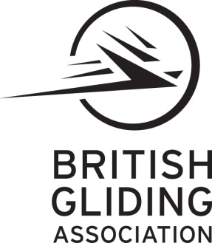

Approval UK.MG.0279

BGA GMP
Sailplane and Self Sustaining Sailplane Maintenance Programme

Ref: BGA/GMP/2005 issue 1 revision 2

Aircraft Type: Registration:

BGA Number: Serial Number:

Engine Type Propeller Type

Owner’s Name

Owner’s Address

British Gliding Association Ltd,
8 Merus Court, Meridian Business Park, Leicester. LE19 1RJ.

