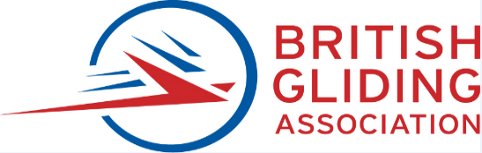

BGA CAO LETTER OF AGREEMENT for Part 21 aircraft

To comply Commission Regulation (EU) No 1321/2014 of 26 November 2014 as retained (and amended in UK domestic law) under the European Union (Withdrawal) Act 2018 Law last amended 20 November 2021, on receipt of this letter of agreement signed by the owner, the BGA will act as the Combined Airworthiness Organization (CAO) in the uncontrolled environment for the aircraft listed at the end of this document.
Both signatories undertake to follow the respective obligations of this arrangement.
The owner certifies, to the best of their belief, that all the information given to the BGA concerning the continuing airworthiness of the aircraft.is accurate and that the aircraft will not be altered without prior approval of the approved organisation (via a BGA inspector).
In case of any non-conformity with this arrangement by either of the signatories, it will become null. In such a case, the owner will retain full responsibility for every task linked to the continuing airworthiness of the aircraft and the owner will undertake to inform the competent authorities of the Member State of registry within two full weeks”.

The BGA will maintain a Combined Airworthiness Organisation approval (CAO) to fulfil the obligations above. This CAO and obligations are detailed in the BGA Airworthiness Exposition and summarised in various owner communications and on the BGA web site.
The aircraft owner/operator obligations and include Part ML.A.201 Responsibilities Regulation (EU) 2020/270 listed below.
- The owner of the aircraft shall be responsible for the continuing airworthiness of the aircraft and shall ensure that no flight takes place unless all the following requirements are met:
- The aircraft is maintained in an airworthy condition.
- Any operational and emergency equipment fitted is correctly installed and serviceable or
clearly identified as unserviceable.
- The airworthiness certificate is valid (no grounding defects, all mandatory items in life, current ARC and annual)

In effect the above requires the following.
- The maintenance of the aircraft is performed in accordance with the owner declared Aircraft Maintenance Program (‘AMP’) specified in Part ML.A.302. (The BGA SDMP 267 does this)
- Have a general understanding of the maintenance programme
- Have a general understanding of Part ML regulation.
- Present the aircraft at an approved maintenance organisation (BGA inspector) as agreed with that organisation.
- Not modify the aircraft without first consulting with a BGA inspector
- Inform the BGA CAO of all maintenance exceptionally carried out without the knowledge of that organisation. i.e. not carried out by a BGA inspector (except Pilot owner maintenance)
- Report all significant defects to the BGA CAO
- Inform the member state of registry and the BGA if the aircraft is sold
- Report occurrences, incidents, and accidents through BGA reporting procedures
- Comply with BGA Laws and Rules for Glider Pilots

I will comply with the above obligations for inclusion in the BGA CAO and I wish to enter the following aircraft:

(Please include Motor Gliders and Tugs that you wish to include in the BGA CAO).

Registration &  BGA Number | Aircraft Type | Aircraft serial  number | Owners/Operators name and address
G-
BGA
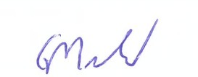

G MacDonald. Chief Technical Officer,
For the British Gliding Association.

Signed………………………………….… Name………..……………….………….Date………..…… as aircraft owner or aircraft operator as required.

Please return a signed copy of this agreement to the BGA and retain a copy in the aircraft files for future reference.

Gordon MacDonald
BGA Chief Technical Officer
CTO@gliding.co.uk
0116 289 2956 / 07767 898103
Visit the BGA web site at www.gliding.co.uk
British Gliding Association Limited
CAA CAO.UK. 0025
UK CAA BCAR APPROVAL: DAI/8378/73
Registered No: 422605 England
VAT No: 238 5224 62
Registered Office: 8 Merus Court, Meridian Business Park, Leicester LE19 1RJ

