General Data Protection Regulation (GDPR) & Gliding Clubs – part III of III

The new GDPR comes into force on 25th May 2018, replacing the Data Protection Act 1998 (DPA).
All organisations that handle personal data will need to comply with the new regulations. GDPR will continue to apply after Britain leaves the EU.
The UK’s independent authority set up to uphold information rights is The Information Commissioner’s’ Office (ICO).
The ICO website contains a great deal of useful information plus a myth busting blog.
The purpose of this document is to give you:
- a brief recap to give context to the notes in this document (but please also re-read the Phase I & II notes);
- a rundown of required documentation;
- an understanding of when consent is required and what the club needs to do to show individuals gave it
- an overview of what to do when someone leaves, and suggestions on how long to hold (which) data;
- GDPR opportunities – using data more effectively to help lighten club management and admin tasks;
- hints and tips on living with GDPR after 25th May 2018;
- actions to be taken now – including the ICO checklist;
- links to further information.

Recap on background information and definitions

Definitions Taken from the ICO guide
‘Personal data’ Any information relating to an identifiable person who can be directly or indirectly identified, in particular by reference to an identifier.
‘Data controller’ A controller determines the purposes and means of processing personal data.
‘Data processor’ A processor is responsible for processing personal data on behalf of a controller.
- The GDPR applies to both ‘controllers’ and ‘processors’
- The GDPR applies to processing carried out by organisations operating within the EU.
- The GDPR does not apply to certain activities including processing covered by the Law Enforcement Directive, processing for national security purposes and processing carried out by individuals purely for personal/household activities.
Full information from the ‘Key Definitions’ section of the ICO guide

Action area 1: Documentation
Following on from the Phase I and II notes, you should now understand the following about your gliding club:
- Personal Data held;
- Data handling processes in use;
- Existing data safeguards;
- How to improve the club’s data security;
- The processes for handling data requests from individuals;
- How the club admin will support and encourage the club members to keep data accurate and up to date, and be able to check accuracy
Now it is time to drop the documentation into the right places within the club’s personal data system.

GDPR Toolkit Kit from S&RA, Gateley plc and Sport England
Sport England funded the work by the Sport & Recreation Alliance and Gateley plc to produce a comprehensive toolkit specifically for British sports clubs. The BGA is not duplicating the toolkit, neither is it amending items within it as that would negate the legal sign off that the toolkit materials have. Clubs will need to adapt the materials as required. Use the kit to work from. Some additional points:

Data Privacy Notices (DPN)
You will need a variety of them, primarily one for adult club members, but also a version for children, volunteers and employees. Remember to include sharing information with the BGA! This is to help you to provide sports (gliding) facilities as part of the contract that was created when the club member purchased their club membership.

Data Protection Policy
Use the Gateley plc version in the Toolkit as a template.

BGA generic Membership Forms
Both the Temporary and Full membership forms have been updated. The Juniors form has been dispensed with. Remember to cross-reference between all the data protection documents and the club’s actual processes. Attach a copy of the DPN to the form (or email a pdf copy by automated response if they sign up online) for them to keep.

Data Protection Lead / Manager
Unless your club employs over 250 people, do not! under any circumstances, call this volunteer (or staff member) a ‘Data Protection Officer’ as this will cross the threshold into the more stringent bracket of GDPR compliance.

Layout of documents
Be as considerate of your readers as possible. Make documents friendly with plenty of white paper. Ensure that it reflects the club ethos – professional, unfussy, friendly and approachable (etc). Use landscape format for electronic versions so that a whole page can be viewed at once.

Action Area 2: Consent
Phase I and II notes set out the 6 legal bases for collecting, processing and holding data, of which two, Contract; and Legal obligation, cover most gliding scenarios.
From ICO the lawful bases for collecting and processing personal data are set out in Article 6 of the GDPR (full details in the ICO guide).
The three legal bases that concern us are:
(a) Consent: the individual has given clear consent for you to process their personal data for a specific purpose
(b) Contract: the processing is necessary for a contract you have with the individual, or because they have asked you to take specific steps before entering into a contract.
(c) Legal obligation: the processing is necessary for you to comply with the law (not including contractual obligations).
ONLY ASK FOR CONSENT WHERE YOU NEED IT – NOT WHERE YOU DON’T!
If the personal data is collected & used to fulfil a specific lawful basis, then seeking consent from the individual is misleading and inherently unfair.

Types of data clubs might collect and process, by basis (some e.g. financial fall into 2 areas)
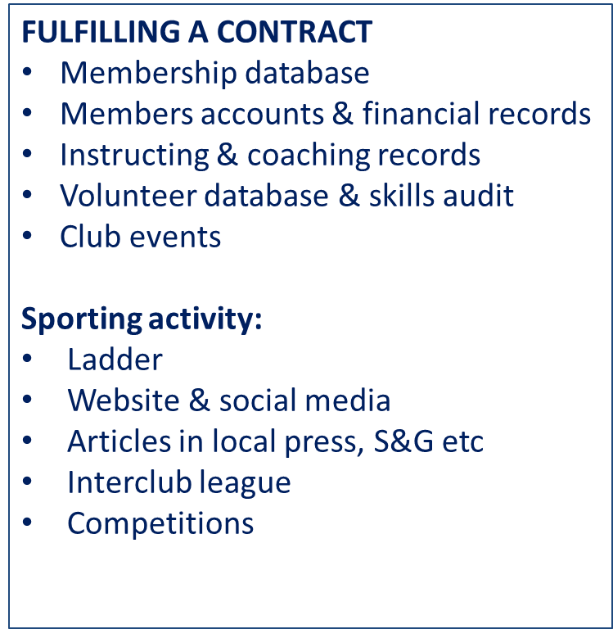
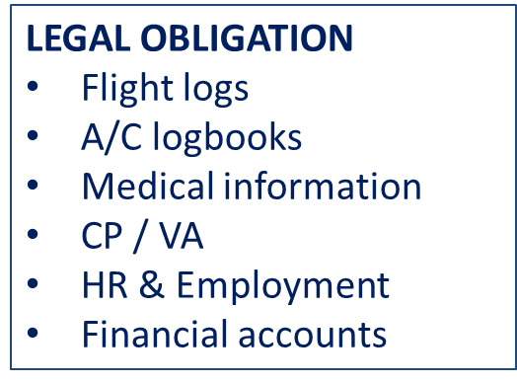
In the Phase II notes, clarification was still required to define whether consent is required to let club members know about club events.
CONSENT
News & events for:
- MEMBERS!
- ex-members
- Non-members
There is a (surprising) legal definition of ‘direct marketing’ which means that clubs MUST gain Consent for directly contacting current members, ex-members & old friends with club news, newsletters and club events, including sport activities.
We have updated the Data Protection section the generic membership forms. We continue to suggest that club members use the forms for membership renewal.
For more information check:
The S&RA GDPR Toolkit Advice Note on Direct Marketing
The ICO Guidance on Consent
The ICO ‘Lawful basis interactive guidance tool’

Consent – record keeping
Whilst most people fielding the GDPR compliance for their clubs are caught up with getting the DPN right, in reality it is this area that is most likely to cause problems.
The generic Membership forms (both Full and Temporary) have been updated to include several tick boxes to cover the different types of direct communication that a club might use to contact club members. Please make sure that this information is accurately used. Probably the quickest way to irritate the naturally litigious person is to contact them when they have not consented for the club to do so.
Store, maintain and use these contact lists separately from other personal data, password protected as necessary.
From ICO’s Guide to GDPR – how should we obtain, record and manage consent:
Good records will also help you to monitor and refresh consent as appropriate. You must keep good records that demonstrate:
Who consented: the name of the individual, or other identifier (eg, online user name, session ID).
When they consented: a copy of a dated document, or online records that include a timestamp; or, for oral consent, a note of the time and date which was made at the time of the conversation.
What they were told at the time: a master copy of the document or data capture form containing the consent statement in use at that time, along with any separate privacy policy or other privacy information, including version numbers and dates matching the date consent was given. If consent was given orally, your records should include a copy of the script used at that time.
How they consented: for written consent, a copy of the relevant document or data capture form. If consent was given online, your records should include the data submitted as well as a timestamp to link it to the relevant version of the data capture form. If consent was given orally, you should keep a note of this made at the time of the conversation - it doesn’t need to be a full record of the conversation.
Whether they have withdrawn consent: and if so, when.

A word on the other areas of the membership forms
Emergency contact information: it is better if people don’t leave this blank. Sharing the personal data is covered by ‘Vital Interest’. Care is required to ensure that this particularly personal information is stored securely, yet is accessible in the event of an emergency. Sufficient senior club personnel should be able to access it to cover scenarios such as being out of contact or involved (& incapacitated) in the emergency.
Statistical information: this section is designed to be rendered anonymous by separating it from the individual club member’s other records. At which point the data ceases to be ‘personal’.
Existing ‘customers’ (members) the ICO myth busting blog has a recent post ‘gaining consent from current customers’.

Action Area 3: what to do when someone leaves; which data should you retain and for how long?
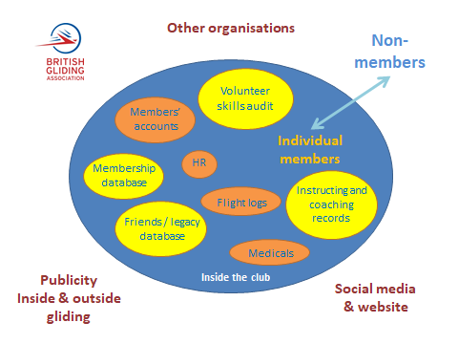
When someone joins or leaves the club, that should trigger a data handling process, because their status has changed. Please dispose of personal data safely!

Shift in lawful bases
When someone is a club member, much of the club’s data processing activity will relate to fulfilling the club member’s membership Contract. When members leave, that lawful basis ceases to exist. This is partly replaced by ‘legitimate interest’. There will be some data that the club will be legally obliged to retain. There is ICO information and a ‘legitimate interest’ test.
This shift in lawful bases applies to all club members, including temporary members (as everyone who takes a launch must be a club member). For CASC clubs that temporary membership will only last for 1 month.
Date of birth: This is the most valuable piece of personal data an individual possesses. When recording personal data do you always need the full DOB? Will year of birth be sufficient? A full DOB is only required to verify someone is old enough for legal purposes e.g. flying solo.

How long should you keep data for?
- Flight logs Long enough to verify with whichever agency is interested e.g. club accountants, HMRC.
- Aircraft logs Long enough to update the individual aircraft records as required annually under regulation.
- Medical records Long enough to evidence that insurance requirements are met. Record the date of expiry.
- Training records As defined under regulation. EASA rules are generally 5 years.
- Accidents Once reported to AAIB and to EASA, not required. But then as required by insurance activity

Data disposal: It is important to understand that the right to erasure is not absolute and only applies in certain circumstances. For instance, the club’s compliance with a legal obligation will override an individual’s request.
What you don’t need to delete – because the data is embedded in records and publications, is not being processed or it is impractical to do.
- Club publications, including on websites and social media (unless they are focus on them solely and/or they are recent and/or the individual(s) affected are requesting that because it has caused upset, offence or is affecting them in some other way)
- Competitions: competitor lists; results; news (someone taking part should expect these to be publicised)
- Club historical documents and archive – gliding heritage matters
Remember: lists of trophy winners, record holders, post holders, club members in any particular year etc should not include dates of birth, addresses, opinion on skill levels, and so on.

GDPR opportunities
Fully understanding the data collected through the normal business of running of the club will:
- help you to run the club more effectively;
- highlight opportunities for communicating with the people on your database;
- increase participation by helping and encouraging people to join in more frequently i.e. getting more people to have more fun gliding.

Your club will be going to great effort to secure consent to communicate with members – ironically because such communications are classified as ‘direct marketing’, so use the contact details to encourage greater participation in:
Gliding activities including flying
Volunteering you will find volunteering resources in the Club Management section of the BGA website
Social events the heart of the club lies in social interaction so create plenty of opportunities throughout the year for people to relax and socialise. Be sure to invite ex-members and recent trial lesson people back to join in too.
Consider automation to reduce admin workload:
- auto responses to online subscription – email relevant documents, receipts and DPNs by return
- online subscription to newsletters – with data automatically being sorted into a mailing list database
- online sign up to membership – with data automatically going into the membership database
Harvest activity data to help inform:
- development of gliding products
- provision of club facilities (including evidence for funding bids)
- sport development and coaching support
There are an increasing number of membership management packages on the market now. They are increasing in sophistication all the time. Keep an eye out for relevant products that will make club management easier.

Hints and tips for keeping up the good work after 25th May 2018

Essentially this is about keeping an eye on the sorts of activities you undertook under Phases I and II of the GDPR compliance process to make sure personal data is safely flowing around your club.
Set and carry out regular reviews:
- keep tabs on who holds what data
- that the data is password protected; on machine with up to date antivirus and security patches
- the mouse holder does not click on dodgy links in emails
- are your systems doing what you need them to do?
Form filling there is something to be said for a unbreakable pen and paper system at the launch point, but the flip side is hours of manual data entry. Many gliding sites have good network coverage nowadays, so online form filling from a smart phone is becoming more practical. Keep an eye on ways to work smarter.

Ongoing support
The BGA Development Officer is available to discuss GDPR matters, and if there is enough demand, will be running discussion workshops around the country over the next few months. If you have questions or need support, please contact alison@gliding.co.uk Please include your phone number on the email (it won’t be stored, or shared with anyone else).
From S&RA: The Sport and Recreation Alliance and Sport England recognise that the journey does not stop on 25 May and that there will a need for ongoing activity beyond that date. With that in mind we have teamed up with Wright Hassall LLP, a legal firm with a strong track record and experience of providing legal and practical GDPR support to sporting organisations and many other sectors. Wright Hassall LLP have also engaged with key policy makers in the Information Commissioner’s Office.
Between the end of May 2018 and March 2019, Wright Hassall LLP will be producing a range of very practical, hands-on resources to help even the smallest sport and recreation organisations understand how to put into practice what is needed to become GDPR compliant. Over the coming months you can expect to see some advice and suggestions that try to help answer the question “Well, how do I actually do this?”, including:
- Simple “how-to” summaries aimed specifically at clubs
- Online media such as videos and podcasts
- FAQ-style summaries of practical issues around personal data.
The BGA will pass on any relevant resources that emerge from this work.

Actions to be taken now
Working towards GDPR compliance is an iterative process, this is the delivery phase. Remember to run through the ICO self-assessment checklist
The BGA will run discussion workshops if required.

Iterative phases for becoming GDPR ready
The BGA will be issuing notes for gliding clubs for each of these phases, using information shared and adapted from the sport sector and ICO.
Phase | Types of work | Likely timing of BGA notes | Factors affecting your action
1 | The 4 sets of actions set out in this document – to map existing personal data that is collected and held; look at data flow around the club; sort out who’s data you can continue to hold | Published | This requires volunteer time and office admin time (if your club employs someone)
2 | Drill down into the legal bases;  Look at systems required for managing data with respect to GDPR compliance and minimum drama;  Consider which IT tools and resources can be usefully included in club processes | Published | Requires volunteer time.  Care required to keep IT solutions straightforward for the IT ‘less literate’ volunteers
3 | Adapt and adopt generic compliance policies and notices | Published | Dependant on sport version availability
4 | Workshops – for discussing aspects of implementing GDPR compliance | May - July | Depending on club need

Further information
The ICO website www.ico.org.uk
Information Commissioner's Office Overview of the General Data Protection Regulation
The ICO have taken the full 300 page monster original GDPR rules and got it down to about 20 short sections and a very helpful index.
S&RA toolkit of guidance and template documents
Written by GDPR experts at the sport sector specialist legal firm Gateley plc. Funded by Sport England.
Information Commissioner's Office Blogs
Series of blogs to dispel a few GDPR myths, key message is ‘don't believe all you read about GDPR’.
Information Commissioner's Office Self-assessment toolkit
Checklists help to assess your compliance with the Data Protection Act.
Information Commissioner's Office data protection guidance for small businesses
Some really nice resources for small organisations - practical and plain English.
BGA: to discuss gliding specific issues in relation to GDPR contact Alison Randle via alison@gliding.co.uk 01453 882 720 or 07910 300 246

