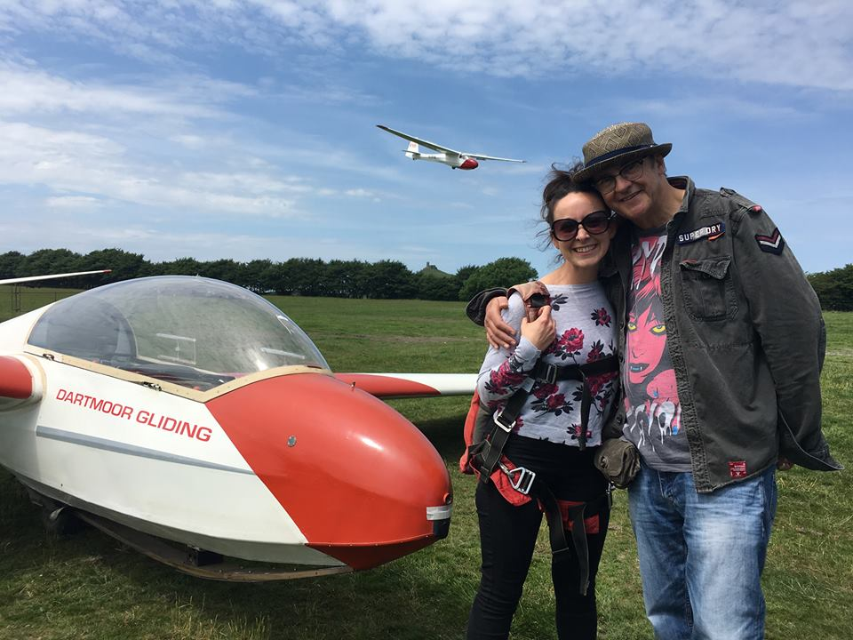
Insert your logo
to identify the sender
Press release 28th October 2018
Insert a headline that describes the content of your press release

Photo caption: adding an image creates interest and visual context.

The introduction to your press release needs to do two fundamental things: spark
the interest of your reader and give them all of the key information they need, in a
nutshell, in bold.
To make it easier for your reader to scan and digest, divide the main body of the press release into several specific sections. In the text you should aim to explain the who, what, when, where, why and how - it’s these questions journalists want to get answers to in their article.

And the easier it is for the journalist to quickly find the main points, the more likely it is that your press release will be picked-up and published.
Another section of your press release should be a quote from a relevant source. “This helps to back-up your story and increase the relevance of your press release,” said Andy Perkins, Chairman of the British Gliding Association.
The best press releases are concise and to the point, consisting of around 250 words.
Remember to include a link to other relevant content in a call-to-action.
End your press release with a short description of your club or other information that could be of interest to the reader. Keep it concise. Visit www.gliding.co.uk for more information.
Add contact details for the person or persons that the reader should
contact for more information:
Rachel Edwards, BGA Marketing Officer, 0116 289 2956 or Rachel@gliding.co.uk

