Example COVID19 Risk Assessment FOR USE BY BGA CLUBS
Risk | Unmitigated  Score | Risk Reduction Measure | Mitigated  Score
Lack of awareness. | Medium | Ensure club members aware of BGA guidance re symptoms and recent exposure limitations before attending the club | Low
Spread due to lack of social distance. | Medium | Maintain 2m distance, or where not possible, maintain 1m distance with face coverings. | Low
Spread due to touching surfaces. | Medium | Clean surfaces. Wear gloves. | Low
Spread due to unavoidable (eg safety related) working in proximity. | Medium | Use face coverings. Minimise time spent in proximity. | Low
Spread due to enclosure in aircraft cockpit. | Medium | Use face coverings providing it is safe to do so. NB – all passengers MUST wear a face covering*. Ventilate cockpit. Minimise flight time to that necessary to achieve the aim of the flight. | Low
Spread due to contaminated cockpit. | Medium | Carry out cleaning before crew change. | Low
Spread due to retrieve. | Medium | Minimise numbers in vehicle.  Use face coverings. | Low

*DfT published guidance July 2020:
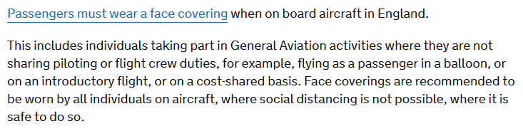

BGA July 2020

