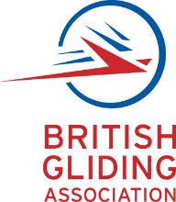
Solo Qualifying Cross Country Completion Certificate

Student pilot _______________________ in aircraft _________________
has been authorised to carry out a solo cross-country flight using the following airfield pairs:
From _______________________ to ________________________________
From _______________________ to ________________________________
Estimated time of departure _________________ date ____________________
This is to certify that the above named pilot and aircraft landed at (airfield)
_______________________ at (time) ______________ on (date) _________________________
The standard of flying observed was satisfactory/unsatisfactory (delete)
The standard of airmanship observed was satisfactory/unsatisfactory (delete)
Comments:

To the best of my knowledge the above pilot was alone in the aircraft and also not accompanied by any other aircraft
Signature:

Name:
Position :
IF NECESSARY: The DTO can be contacted as below
DTO name ________________________________________________________________________
Contact name _____________________________________ Telephone _____________________
The above Solo Qualifying Cross Country flight was conducted in accordance with the appropriate provisions of Subpart SPL - SFCL.150

Instructor Signature _______________________________________

Instructor Name __________________________ Licence Number ________________________

