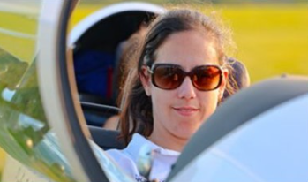
Francesca Roberts
WWGC Team GB – Standard Class

Flies: LS8

Home Club: The Gliding Centre, Husbands Bosworth

Fran’s competition highlights are: 8th at the 2022 Women’s World Championships (Husbands Bosworth, UK, Standard Class); 5th at the 2024 Standard Class Nationals (UK).

Francesca (“Fran”) Roberts’ journey into aviation began before she could even walk. Raised by two passionate glider pilots, she spent her childhood on the airfield, watching and dreaming of the skies. She soloed on her 16th birthday and was quickly drawn to competitive cross-country flying, securing a place on the British Women’s Team at just 23 years old for the 2011 World Championships in Sweden.

While gliding has always been a part of her life, Fran’s career took her in another high-performance direction—healthcare. A nervous system-focused chiropractor, she owns and operates two thriving clinics in the UK, leading a dedicated team of 11 professionals. Balancing her passion for flying with a demanding career, she temporarily stepped back from competition to explore wave flying in Wales, take on new challenges, and even embark on an unforgettable adventure walking the Pacific Crest Trail from Mexico to Canada.

Now a mother of two, Fran’s love for soaring has never faded. Her son Jack (5) has already attended three Women’s World Championships and had his first taste of high-level mixed competition watching his dad compete at the World Championships. Meanwhile, Hugo (1) has been along for the ride from the very start - his first World Championships experience was in 2023, when Fran competed while five months pregnant, soaring through the skies of Spain with him already in the cockpit.

Between flying, running her business, supporting her husband in his own World Championship campaigns, and renovating a house, Fran’s life is a whirlwind of adventure. Yet, she always finds her way back to the sky. Gliding, for her, is more than just a sport—it’s an unparalleled connection with nature, a test of skill and endurance, and a constant source of inspiration. Whether climbing to 24,500 feet over Aboyne at sunrise or chasing her next big milestone—the 750km diploma—Fran continues to push her limits and inspire others to chase their own dreams.

